7PAM2000 Applied Data Science 1

Assignment 1: Visualisation

**STUDENT NAME: B GEETHA**

**STUDENT ID: 22095828**

**Table of Contents**

1 Line Plot 2

2 Cat Plot 3

3 Scatter Plot 4

References 5

**List of Figures**

Figure 1: First Visualization – Line Plot 2

Figure 2: Second Visualization – Cat Plot 3

Figure 3: Third Visualization - Scatter Plot 4

# Line Plot

The line plot shows the variation of crude birth and death rates against time for the 'Arab World' area. The data comes from the World Development Indicators dataset which covers several years. Demographic changes are revealed through the plot of birth and death rates. The crude birth rate is indicated by the blue line, or the number of births per 100 people, and the crude death rate depicted through the orange line refers to the number of deaths. Over time, the plot allows viewers to view trends and periods of marked change and finally get a holistic picture of population dynamics in the Arab world. The graphical representation helps in highlighting the likely associations or disparities between birth and death rates, which provides a more detailed analysis of demographic dynamics within that region (Raidou et al. 2019).

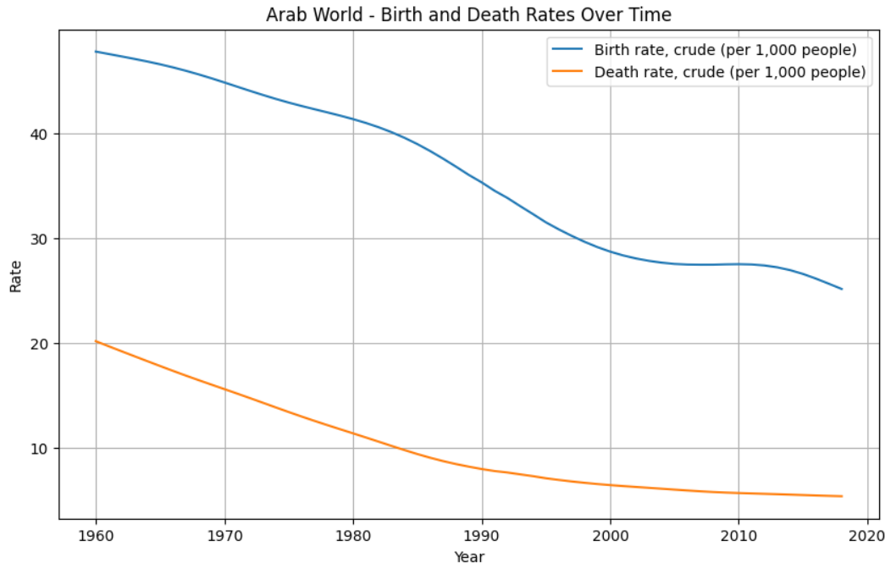

Figure 1: First Visualization – Line Plot

# Cat Plot

The given figure of a stacked bar plot depicts the landscape for carbon dioxide (CO2) emissions in 2010, illustrating each country’s fuel contribution. Every single bar the embodies total CO2 emissions of a country, while unique colors inside bars reflect parts contributed by different fuel types. As a result, the attached key helps decipher colors to fuel categories. This vignette is useful in the comparative analysis of how CO2 emissions are driven by a large variety of sources across different countries. The layered characteristic of each bar makes it simple to compare and quantify significance in emission profiles created when different types of fuels were utilized in the nations represented by the corresponding bars. Policymakers, environmental scientists, and those who are working to develop models to lower emissions or support the transition to sustainable energy this kind of information is greatly helpful for them. To provide a more comprehensive view of the global carbon footprint and to focus attention on specific areas for climate change mitigation, the plot supports the emergence of trends and variation in energy utilization by nation (Seaborn, 2023).

Figure 2: Second Visualization – Cat Plot

# Scatter Plot

The scatter plot presents a deep understanding of the connection that exists between life expectancy and birth rate across many countries. Every dot on a graph representing a country's birth rate and life expectancy is an unexpected value. In a scatter plot to help with the identification of particular nations, each point is color-coded with a distinct color. With the help of this graph, we can understand a complex illustration of the possible connections between changes in life expectancy and birth rates. One may quickly identify trends or patterns that might point to a connection between two demographic metrics by using a scatter plot. Analysts, experts, researchers, and policymakers who constantly seek solutions for population dynamics projects and public health can use scatter plot data to determine the complex link between demographic components (Raidou et al. 2019).

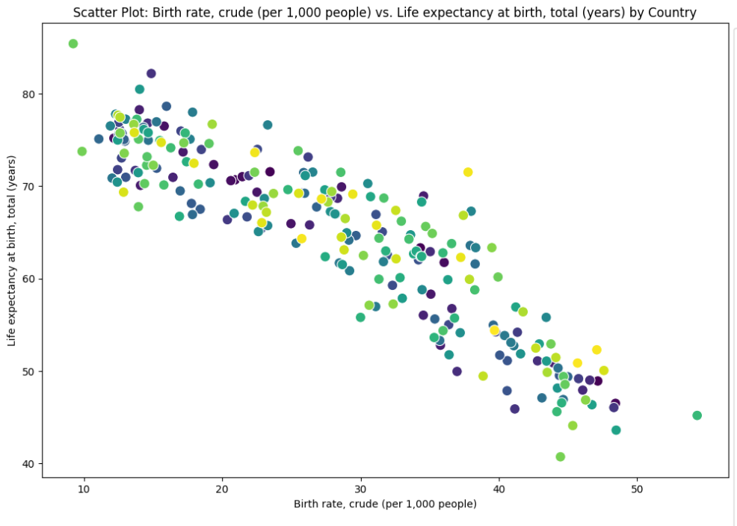

Figure 3: Third Visualization - Scatter Plot

# References

Raidou, R.G., Gröller, M.E. and Eisemann, M., 2019. Relaxing dense scatter plots with pixel-based mappings. *IEEE Transactions on Visualization and Computer Graphics*, *25*(6), pp.2205-2216.

Seaborn. 2023. *seaborn.catplot — seaborn 0.13.1 documentation*. [online] Available at: https://seaborn.pydata.org/generated/seaborn.catplot.html [Accessed 18 Jan. 2024].

‌